STAT 8120 – Module 6 Homework

Due 3/15/2020

Connor Armstrong

***6.5*** *An engineer is interested in the effects of cutting speed (A), tool geometry (B), and cutting angle (C) on the life (in hours) of a machine tool. Two levels of each factor are chosen, and three replicates of a 23 factorial design are run. The results are as follows:*

**6.5 Conditions**

|  |
| --- |
| *6.53 For the REST OF THE SEMESTER, always give Residual Analysis for any problem in SG3 Table 7 order. Use RA comparisons to justify the need for a transformation (with vs. without). Report multiple Tukey comparisons using a PC Bar Plot, discuss sigma distances. Give factor levels producing an optimum.*  *6.5+ Use both SAS and Minitab. If necessary, use JMP instead of SAS or Minitab to get desired output.*  *Do NOT repeat discussions. Circle one common numeric value in outputs.* |

**Table 6.5.1**

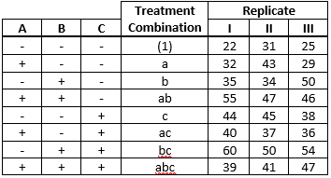

***6.5.a*** *Estimate the factor effects. Which effects appear to be large?*

The data were analyzed using Minitab. The output is below. The factor effects for Tool Geometry, Cutting Angle, and the interaction effect between Cutting Speed and Cutting Angle are significant and appear to be large. This is confirmed using a normal probability plot of the standardized effects on page 2, indicating that these factors do not follow the trend line of the less significant factors.

P6.5

**Factorial Regression: Life Hours versus Cutting Speed, Tool Geometry, Cutting Angle**

**Coded Coefficients**

|  |  |  |  |  |  |  |
| --- | --- | --- | --- | --- | --- | --- |
| **Term** | **Effect** | **Coef** | **SE Coef** | **T-Value** | **P-Value** | **VIF** |
| Constant |  | 40.83 | 1.12 | 36.42 | 0.000 |  |
| Cutting Speed | 0.33 | 0.17 | 1.12 | 0.15 | 0.884 | 1.00 |
| Tool Geometry | 11.33 | 5.67 | 1.12 | 5.05 | 0.000 | 1.00 |
| Cutting Angle | 6.83 | 3.42 | 1.12 | 3.05 | 0.008 | 1.00 |
| Cutting Speed*Tool Geometry | -1.67 | -0.83 | 1.12 | -0.74 | 0.468 | 1.00 |
| Cutting Speed*Cutting Angle | -8.83 | -4.42 | 1.12 | -3.94 | 0.001 | 1.00 |
| Tool Geometry*Cutting Angle | -2.83 | -1.42 | 1.12 | -1.26 | 0.224 | 1.00 |
| Cutting Speed*Tool Geometry*Cutting Angle | -2.17 | -1.08 | 1.12 | -0.97 | 0.348 | 1.00 |

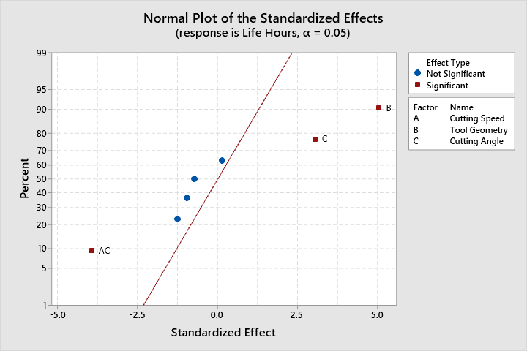

**Analysis of Variance**

|  |  |  |  |  |  |
| --- | --- | --- | --- | --- | --- |
| **Source** | **DF** | **Adj SS** | **Adj MS** | **F-Value** | **P-Value** |
| Model | 7 | 1612.67 | 230.381 | 7.64 | 0.000 |
| Linear | 3 | 1051.50 | 350.500 | 11.62 | 0.000 |
| Cutting Speed | 1 | 0.67 | 0.667 | 0.02 | 0.884 |
| Tool Geometry | 1 | 770.67 | 770.667 | 25.55 | 0.000 |
| Cutting Angle | 1 | 280.17 | 280.167 | 9.29 | 0.008 |
| 2-Way Interactions | 3 | 533.00 | 177.667 | 5.89 | 0.007 |
| Cutting Speed*Tool Geometry | 1 | 16.67 | 16.667 | 0.55 | 0.468 |
| Cutting Speed*Cutting Angle | 1 | 468.17 | 468.167 | 15.52 | 0.001 |
| Tool Geometry*Cutting Angle | 1 | 48.17 | 48.167 | 1.60 | 0.224 |
| 3-Way Interactions | 1 | 28.17 | 28.167 | 0.93 | 0.348 |
| Cutting Speed*Tool Geometry*Cutting Angle | 1 | 28.17 | 28.167 | 0.93 | 0.348 |
| Error | 16 | 482.67 | 30.167 |  |  |
| Total | 23 | 2095.33 |  |  |  |

***6.5.b*** *Use the analysis of variance to confirm your conclusions for part (a).*

The p-values for Tool Geometry, Cutting Angle, and the interaction effect between Cutting Speed and Cutting Angle are all significant and less than the specified significance level of 0.05.

***6.5.c*** *Write down a regression model for predicting tool life (in hours) based on the results of this experiment.*

**Regression Equation in Uncoded Units**

|  |  |  |
| --- | --- | --- |
| Life Hours | = | 40.83 + 0.17 Cutting Speed + 5.67 Tool Geometry + 3.42 Cutting Angle - 0.83 Cutting Speed*Tool Geometry - 4.42 Cutting Speed*Cutting Angle - 1.42 Tool Geometry*Cutting Angle - 1.08 Cutting Speed*Tool Geometry*Cutting Angle |

***6.5.d*** *Analyze the residuals. Are there any obvious problems?*

Residual plots for the Factorial Regression model are displayed on the following page. The Anderson Darling test for normality has a p-value of 0.069 which is marginal. The model would likely improve by removing the nonsignificant interaction factors. Having no run order information, the independence assumption cannot be verified and the versus order plot cannot be analyzed.

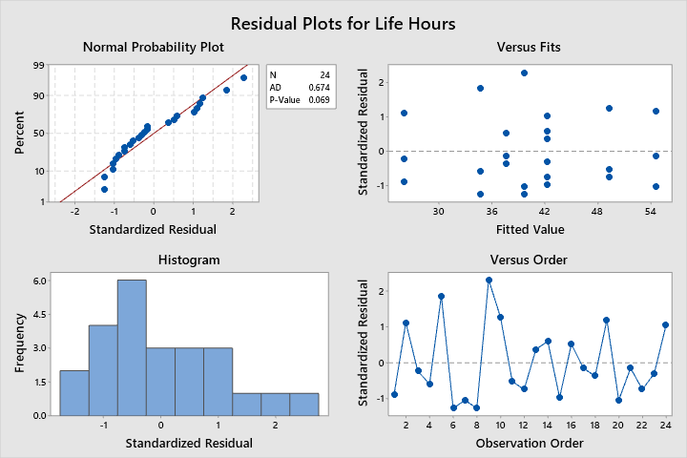

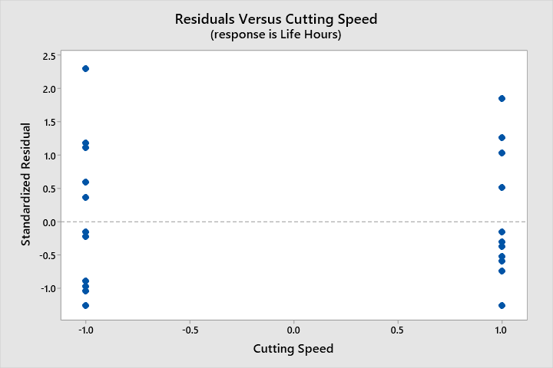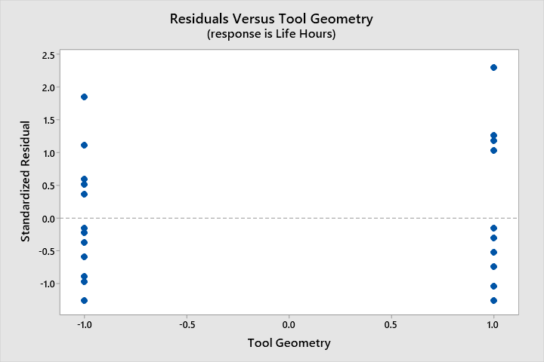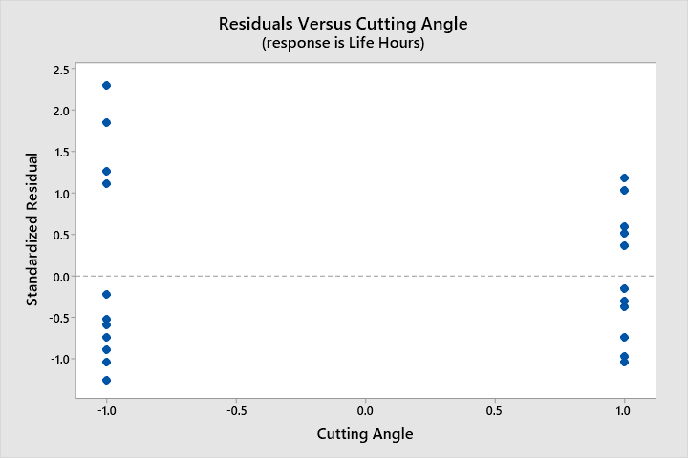

The residual plots do not indicate a significant non-homogeneity of variance by factor level. There is one potential outlier, observation 9 at 2.3 sigma from the estimated value of Life hours. It is expected to have 5% of values outside 2 sigma from the expected value in a normal distribution.

**Fits and Diagnostics for Unusual Observations**

|  |  |  |  |  |  |
| --- | --- | --- | --- | --- | --- |
| **Obs** | **Life Hours** | **Fit** | **Resid** | **Std Resid** |  |
| 9 | 50.00 | 39.67 | 10.33 | 2.30 | R |

*R  Large residual*

Levene’s test of homogeneity of variance for significant factors verifies the homogeneity of variance assumption.

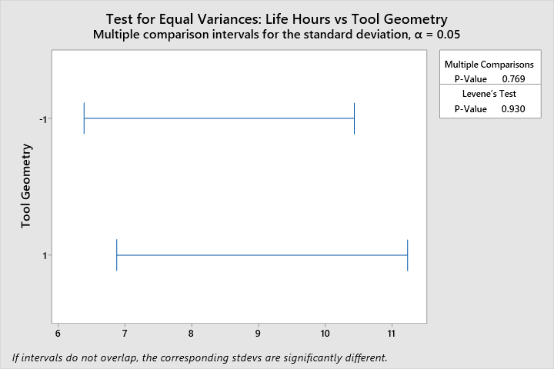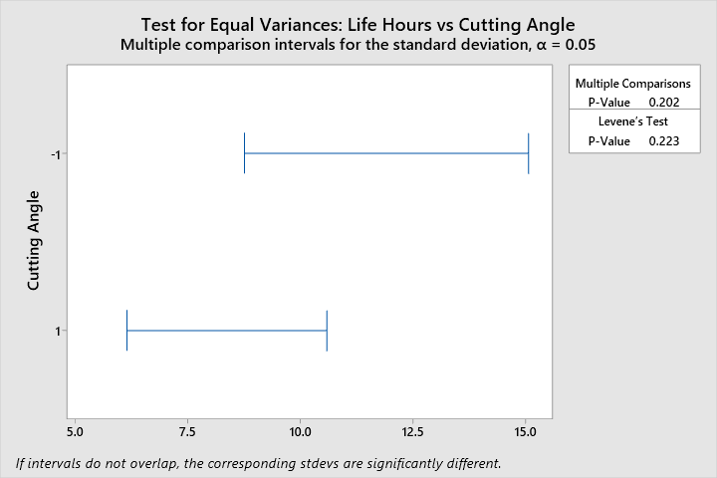

***6.5.e*** *On the basis of an analysis of main effect and interaction plots, what coded factor levels of A, B, and C would you recommend using?*

The main effect plots for tool geometry and cutting angle indicate that the +1 option is likely better than the -1 option for both factors. Cutting speed is not significant and does not make a significant difference in tool life. The interaction between cutting speed and cutting angle is significant, and the combination cutting speed -1 with cutting angle 1 has a significantly higher mean tool life, in hours.

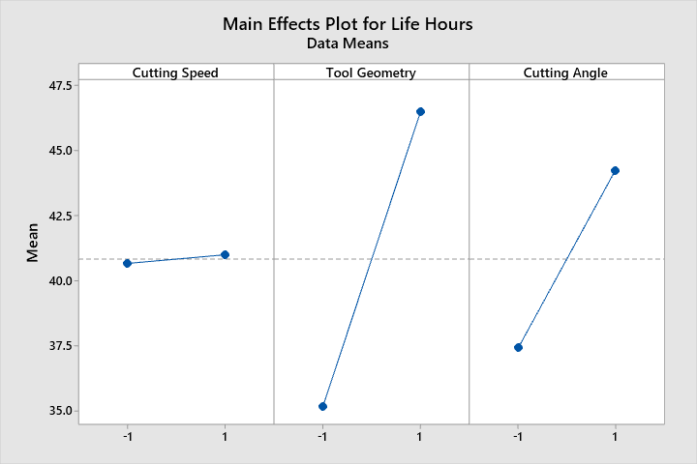

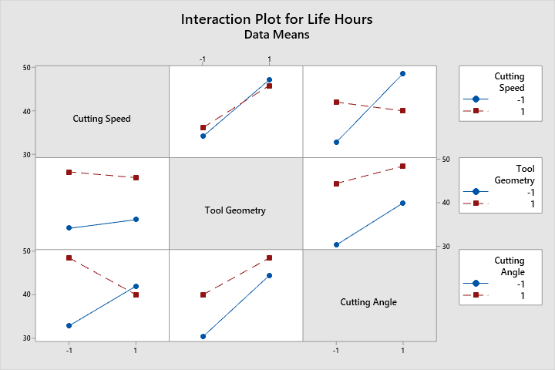

Therefore, the combination (Cutting Speed, Tool Geometry, Cutting Angle) = (-1, 1, 1) is the best combination of factors to yield the highest tool life.

The factorial analysis was also implemented in SAS, per condition 6.5+. The SAS code and output is below.

libname hw6 "C:\Users\conno\OneDrive\Desktop\STAT 8120 - Applied Experimental Design\Module 6";

**run**;

**proc** **import** datafile = "C:\Users\conno\OneDrive\Desktop\STAT 8120 - Applied Experimental Design\Module 6\S8120Ch6Data122317.xlsx"

out = hw6.q1

DBMS = xlsx

Replace;

sheet = "P6.5";

**run**;

**proc** **contents** data = hw6.q1;

**run**;

ods rtf;

ods graphics on;

**proc** **glm** data = hw6.q1 plots=diagnostics;

class cutting_speed tool_geometry cutting_angle;

model life_hours = cutting_speed | tool_geometry | cutting_angle;

output out = stdres student = stdresidual;

Title "SAS Factorial Analysis for Problem 6.5";

**run**;

LSMeans cutting_speed | tool_geometry | cutting_angle / Pdiff = All;

**run**;

Means cutting_speed tool_geometry cutting_angle / LSD;

**run**;

**proc** **univariate** data = stdres normal;

var stdresidual;

qqplot stdresidual / normal(mu=est sigma=est);

histogram/normal;

**run**;

**proc** **sgplot** data = stdres;

scatter x=tool_geometry y=stdresidual;

**run**;

**proc** **sgplot** data = stdres;

scatter x=cutting_angle y=stdresidual;

**run**;

ods graphics off;

ods rtf close;

**quit**;

| **Source** | **DF** | **Sum of Squares** | **Mean Square** | **F Value** | **Pr > F** |
| --- | --- | --- | --- | --- | --- |
| **Model** | 7 | 1612.666667 | 230.380952 | 7.64 | 0.0004 |
| **Error** | 16 | 482.666667 | 30.166667 |  |  |
| **Corrected Total** | 23 | 2095.333333 |  |  |  |

| **Source** | **DF** | **Type I SS** | **Mean Square** | **F Value** | **Pr > F** |
| --- | --- | --- | --- | --- | --- |
| **Cutting_Speed** | 1 | 0.6666667 | 0.6666667 | 0.02 | 0.8837 |
| **Tool_Geometry** | 1 | 770.6666667 | 770.6666667 | 25.55 | 0.0001 |
| **Cutting_S*Tool_Geome** | 1 | 16.6666667 | 16.6666667 | 0.55 | 0.4681 |
| **Cutting_Angle** | 1 | 280.1666667 | 280.1666667 | 9.29 | 0.0077 |
| **Cutting_S*Cutting_An** | 1 | 468.1666667 | 468.1666667 | 15.52 | 0.0012 |
| **Tool_Geom*Cutting_An** | 1 | 48.1666667 | 48.1666667 | 1.60 | 0.2245 |
| **Cuttin*Tool_G*Cuttin** | 1 | 28.1666667 | 28.1666667 | 0.93 | 0.3483 |



| **Tool_Geometry** | **Life_Hours LSMEAN** | **H0:LSMean1=LSMean2** |
| --- | --- | --- |
| **Pr > |t|** |
| **1** | 46.5000000 | 0.0001 |
| **-1** | 35.1666667 |  |



| **Cutting_Angle** | **Life_Hours LSMEAN** | **H0:LSMean1=LSMean2** |
| --- | --- | --- |
| **Pr > |t|** |
| **1** | 44.2500000 | 0.0077 |
| **-1** | 37.4166667 |  |



| **Least Squares Means for effect Cutting_S*Cutting_An Pr > |t| for H0: LSMean(i)=LSMean(j)  Dependent Variable: Life_Hours** | | | | |
| --- | --- | --- | --- | --- |
| **i/j** | **1** | **2** | **3** | **4** |
| **1** |  | 0.9206 | 0.0704 | 0.1495 |
| **2** | 0.9206 |  | 0.2115 | 0.0472 |
| **3** | 0.0704 | 0.2115 |  | 0.0008 |
| **4** | 0.1495 | 0.0472 | 0.0008 |  |















***6.22*** *The effect estimates from a 24 factorial design are as follows: ABCD = −1.5138, ABC = −1.2661, ABD = −0.9852, ACD = −0.7566, BCD = −0.4842, CD = −0.0795, BD = −0.0793, AD = 0.5988, BC = 0.9216, AC = 1.1616, AB = 1.3266, D = 4.6744, C = 5.1458, B = 8.2469, and A = 12.7151. Are you comfortable with the conclusions that all main effects are active?*

|  |
| --- |
| ***6.225*** *Prepare normal & half-normal prob plots (p. 262).* |

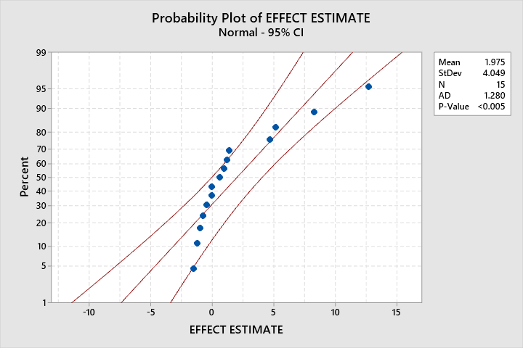

The conclusion that factor effects *D = 4.6744, C = 5.1458, B = 8.2469, and A = 12.7151* are active is well founded, given they do not follow the linear trend of the rest of the factors in the normal probability plot. The half-normal probability plot below indicates that the same conclusion can be drawn for the absolute value of the effect estimates.

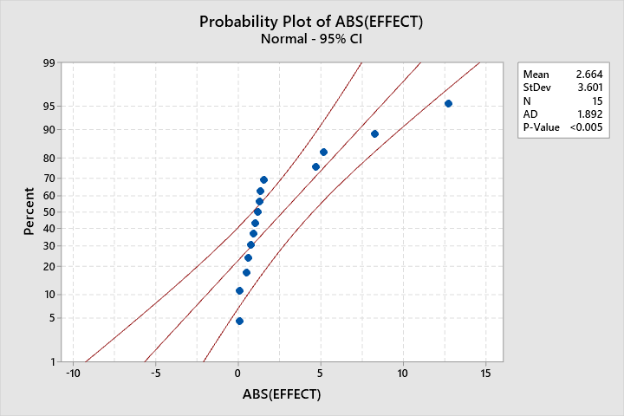

***6.43*** *An article in Quality and Reliability Engineering International (2010, Vol. 26, pp. 223–233) presents a 25 factorial design. The experiment is shown in Table P6.12.*

|  |
| --- |
| ***6.435.5*** *CAUTION: Minitab labels prob plot factors ABC even if factors EFH?* |

***6.43.a*** *Analyze the data from this experiment. Identify the significant factors and interactions.*

The data was analyzed using Minitab, and some of the output is below.

**Coded Coefficients**

|  |  |  |  |  |  |  |
| --- | --- | --- | --- | --- | --- | --- |
| **Term** | **Effect** | **Coef** | **SE Coef** | **T-Value** | **P-Value** | **VIF** |
| Constant |  | 10.18 | * | * | * |  |
| A | 3.232 | 1.616 | * | * | * | 1.00 |
| B | 0.08687 | 0.04344 | * | * | * | 1.00 |
| C | -0.02437 | -0.01219 | * | * | * | 1.00 |
| D | 5.977 | 2.988 | * | * | * | 1.00 |
| E | 4.376 | 2.188 | * | * | * | 1.00 |
| A*B | 2.473 | 1.237 | * | * | * | 1.00 |
| A*C | -0.003125 | -0.001562 | * | * | * | 1.00 |
| A*D | 3.333 | 1.667 | * | * | * | 1.00 |
| A*E | 2.054 | 1.027 | * | * | * | 1.00 |
| B*C | -0.3906 | -0.1953 | * | * | * | 1.00 |
| B*D | -0.02688 | -0.01344 | * | * | * | 1.00 |
| B*E | 2.567 | 1.283 | * | * | * | 1.00 |
| C*D | 0.006875 | 0.003437 | * | * | * | 1.00 |
| C*E | 0.6031 | 0.3016 | * | * | * | 1.00 |
| D*E | 2.779 | 1.390 | * | * | * | 1.00 |
| A*B*C | 0.5006 | 0.2503 | * | * | * | 1.00 |
| A*B*D | -0.6906 | -0.3453 | * | * | * | 1.00 |
| A*B*E | 2.371 | 1.185 | * | * | * | 1.00 |
| A*C*D | -0.12687 | -0.06344 | * | * | * | 1.00 |
| A*C*E | -0.5181 | -0.2591 | * | * | * | 1.00 |
| A*D*E | 1.8031 | 0.9016 | * | * | * | 1.00 |
| B*C*D | 0.6106 | 0.3053 | * | * | * | 1.00 |
| B*C*E | 0.3419 | 0.1709 | * | * | * | 1.00 |
| B*D*E | -0.07937 | -0.03969 | * | * | * | 1.00 |
| C*D*E | 0.7919 | 0.3959 | * | * | * | 1.00 |
| A*B*C*D | -0.14812 | -0.07406 | * | * | * | 1.00 |
| A*B*C*E | -0.3694 | -0.1847 | * | * | * | 1.00 |
| A*B*D*E | 0.8144 | 0.4072 | * | * | * | 1.00 |
| A*C*D*E | 0.2556 | 0.1278 | * | * | * | 1.00 |
| B*C*D*E | -0.14937 | -0.07469 | * | * | * | 1.00 |
| A*B*C*D*E | -0.7106 | -0.3553 | * | * | * | 1.00 |

Minitab cannot compute the p-values for the terms in the model because the degrees of freedom for residual error happens to be 0. This can be remedied by making a determination of which interaction terms to eliminate from the model. The interaction term with the smallest absolute value of effect will be eliminated, in this case it is the interaction between factors A and C (-0.003125). The new model was computed, and the results are displayed in the table on the next page.

All terms, apart from C, B*D, and C*D have significant p-values less than the specified significance level of 0.05. The half normal probability plot of the absolute standardized effects on the next page shows the effects, in order of significance, D, E, A*D, A, D*E, B*E, A*B, A*B*E, A*E, and A*D*E do not follow the trend of the other terms, and are therefore more significant to the model than the other terms.

**Coded Coefficients**

|  |  |  |  |  |  |  |
| --- | --- | --- | --- | --- | --- | --- |
| **Term** | **Effect** | **Coef** | **SE Coef** | **T-Value** | **P-Value** | **VIF** |
| Constant |  | 10.1803 | 0.0016 | 6515.40 | 0.000 |  |
| A | 3.23188 | 1.61594 | 0.00156 | 1034.20 | 0.001 | 1.00 |
| B | 0.08687 | 0.04344 | 0.00156 | 27.80 | 0.023 | 1.00 |
| C | -0.02437 | -0.01219 | 0.00156 | -7.80 | 0.081 | 1.00 |
| D | 5.97688 | 2.98844 | 0.00156 | 1912.60 | 0.000 | 1.00 |
| E | 4.37562 | 2.18781 | 0.00156 | 1400.20 | 0.000 | 1.00 |
| A*B | 2.47312 | 1.23656 | 0.00156 | 791.40 | 0.001 | 1.00 |
| A*D | 3.33313 | 1.66656 | 0.00156 | 1066.60 | 0.001 | 1.00 |
| A*E | 2.05438 | 1.02719 | 0.00156 | 657.40 | 0.001 | 1.00 |
| B*C | -0.39063 | -0.19531 | 0.00156 | -125.00 | 0.005 | 1.00 |
| B*D | -0.02687 | -0.01344 | 0.00156 | -8.60 | 0.074 | 1.00 |
| B*E | 2.56687 | 1.28344 | 0.00156 | 821.40 | 0.001 | 1.00 |
| C*D | 0.00687 | 0.00344 | 0.00156 | 2.20 | 0.272 | 1.00 |
| C*E | 0.60312 | 0.30156 | 0.00156 | 193.00 | 0.003 | 1.00 |
| D*E | 2.77938 | 1.38969 | 0.00156 | 889.40 | 0.001 | 1.00 |
| A*B*C | 0.50063 | 0.25031 | 0.00156 | 160.20 | 0.004 | 1.00 |
| A*B*D | -0.69063 | -0.34531 | 0.00156 | -221.00 | 0.003 | 1.00 |
| A*B*E | 2.37063 | 1.18531 | 0.00156 | 758.60 | 0.001 | 1.00 |
| A*C*D | -0.12687 | -0.06344 | 0.00156 | -40.60 | 0.016 | 1.00 |
| A*C*E | -0.51813 | -0.25906 | 0.00156 | -165.80 | 0.004 | 1.00 |
| A*D*E | 1.80312 | 0.90156 | 0.00156 | 577.00 | 0.001 | 1.00 |
| B*C*D | 0.61062 | 0.30531 | 0.00156 | 195.40 | 0.003 | 1.00 |
| B*C*E | 0.34188 | 0.17094 | 0.00156 | 109.40 | 0.006 | 1.00 |
| B*D*E | -0.07938 | -0.03969 | 0.00156 | -25.40 | 0.025 | 1.00 |
| C*D*E | 0.79188 | 0.39594 | 0.00156 | 253.40 | 0.003 | 1.00 |
| A*B*C*D | -0.14812 | -0.07406 | 0.00156 | -47.40 | 0.013 | 1.00 |
| A*B*C*E | -0.36938 | -0.18469 | 0.00156 | -118.20 | 0.005 | 1.00 |
| A*B*D*E | 0.81438 | 0.40719 | 0.00156 | 260.60 | 0.002 | 1.00 |
| A*C*D*E | 0.25563 | 0.12781 | 0.00156 | 81.80 | 0.008 | 1.00 |
| B*C*D*E | -0.14938 | -0.07469 | 0.00156 | -47.80 | 0.013 | 1.00 |
| A*B*C*D*E | -0.71063 | -0.35531 | 0.00156 | -227.40 | 0.003 | 1.00 |

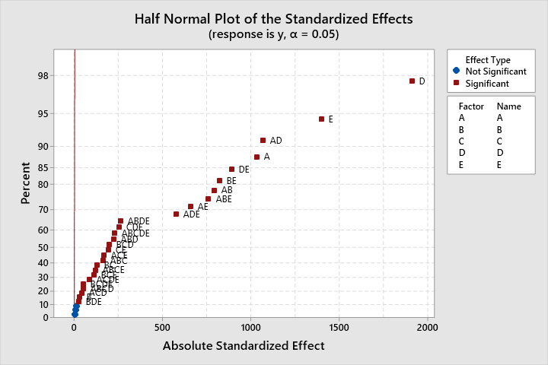

***6.43.b*** *Analyze the residuals from this experiment. Are there any indications of model inadequacy or violations of the assumptions?*

All standardized residuals were 1 or -1, which would have violated the normality of residuals assumption. The factor C, being insignificant, and factors which included C were removed from the model.

**Coded Coefficients**

|  |  |  |  |  |  |  |
| --- | --- | --- | --- | --- | --- | --- |
| **Term** | **Effect** | **Coef** | **SE Coef** | **T-Value** | **P-Value** | **VIF** |
| Constant |  | 10.180 | 0.214 | 47.66 | 0.000 |  |
| A | 3.232 | 1.616 | 0.214 | 7.57 | 0.000 | 1.00 |
| B | 0.087 | 0.043 | 0.214 | 0.20 | 0.841 | 1.00 |
| D | 5.977 | 2.988 | 0.214 | 13.99 | 0.000 | 1.00 |
| E | 4.376 | 2.188 | 0.214 | 10.24 | 0.000 | 1.00 |
| A*B | 2.473 | 1.237 | 0.214 | 5.79 | 0.000 | 1.00 |
| A*D | 3.333 | 1.667 | 0.214 | 7.80 | 0.000 | 1.00 |
| A*E | 2.054 | 1.027 | 0.214 | 4.81 | 0.000 | 1.00 |
| B*D | -0.027 | -0.013 | 0.214 | -0.06 | 0.951 | 1.00 |
| B*E | 2.567 | 1.283 | 0.214 | 6.01 | 0.000 | 1.00 |
| D*E | 2.779 | 1.390 | 0.214 | 6.51 | 0.000 | 1.00 |
| A*B*D | -0.691 | -0.345 | 0.214 | -1.62 | 0.126 | 1.00 |
| A*B*E | 2.371 | 1.185 | 0.214 | 5.55 | 0.000 | 1.00 |
| A*D*E | 1.803 | 0.902 | 0.214 | 4.22 | 0.001 | 1.00 |
| B*D*E | -0.079 | -0.040 | 0.214 | -0.19 | 0.855 | 1.00 |
| A*B*D*E | 0.814 | 0.407 | 0.214 | 1.91 | 0.075 | 1.00 |

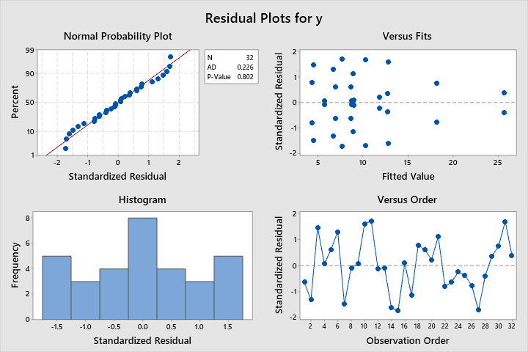

The residual plots are displayed above. The residuals are normally distributed, with a p-value of 0.802 for the Anderson-Darling normality test. The versus fits plot indicates a potential funnel shape, indicating that a transformation may improve the model. There are no outliers, having no standardized residuals > 2. The independence assumption cannot be verified in absence of run order information. The residual plots on the next page do not indicate any concerns with model adequacy or assumption violations.

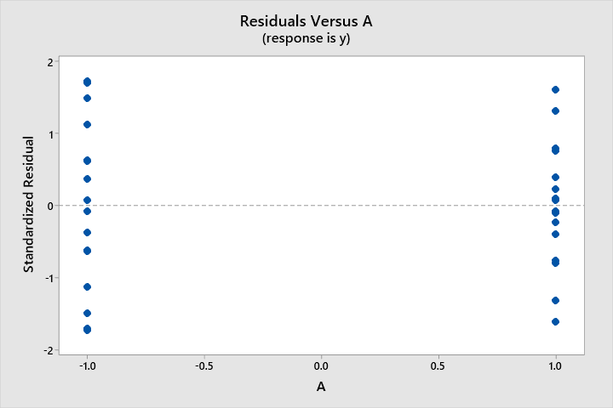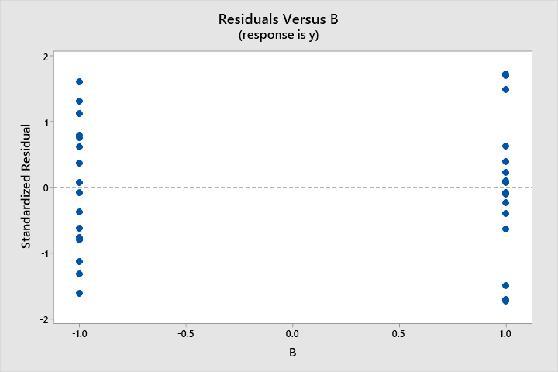

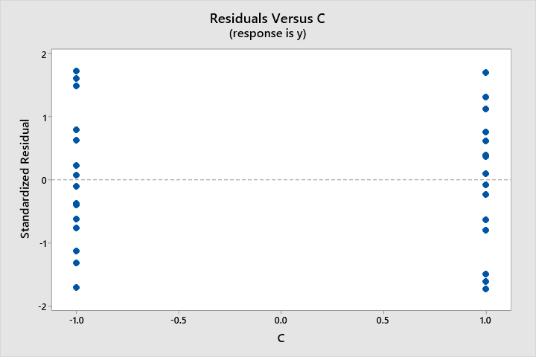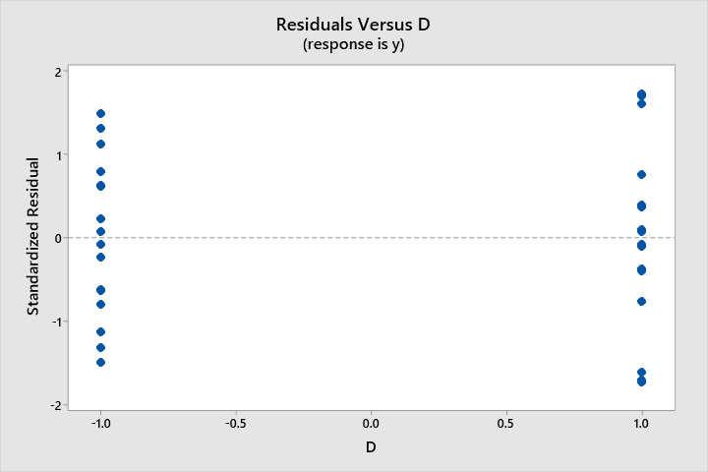

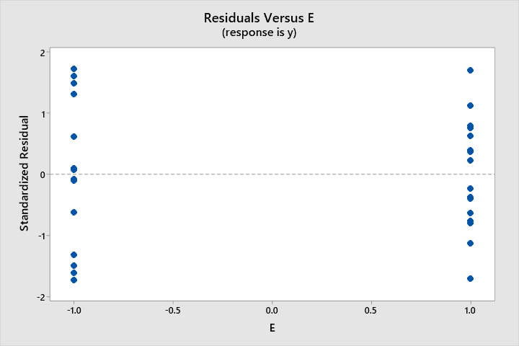

***6.43.c*** *One of the factors from this experiment does not seem to be important. If you drop this factor, what type of design remains? Analyze the data using the full factorial model for only the four active factors. Compare your results with those obtained in part (a).*

Having removed the “C” factors from the experiment, the new design is a 24 factorial design. The same factors, D, E, A*D, A, D*E, B*E, A*B, A*B*E, A*E, and A*D*E, are very significant in the new model, as indicated in the half probability plot on the next page.

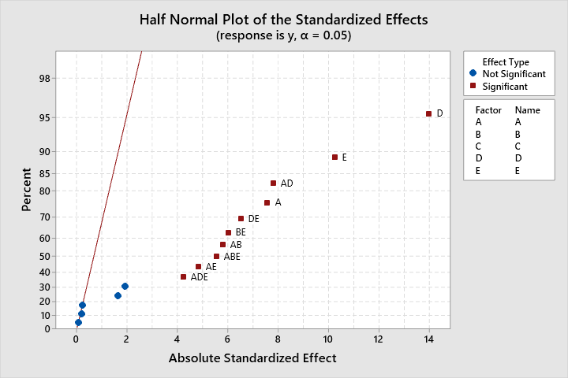

The ANOVA table for the new model:

**Analysis of Variance**

|  |  |  |  |  |  |
| --- | --- | --- | --- | --- | --- |
| **Source** | **DF** | **Adj SS** | **Adj MS** | **F-Value** | **P-Value** |
| Model | 15 | 888.802 | 59.253 | 40.58 | 0.000 |
| Linear | 4 | 522.574 | 130.643 | 89.48 | 0.000 |
| A | 1 | 83.560 | 83.560 | 57.23 | 0.000 |
| B | 1 | 0.060 | 0.060 | 0.04 | 0.841 |
| D | 1 | 285.784 | 285.784 | 195.74 | 0.000 |
| E | 1 | 153.169 | 153.169 | 104.91 | 0.000 |
| 2-Way Interactions | 6 | 286.088 | 47.681 | 32.66 | 0.000 |
| A*B | 1 | 48.931 | 48.931 | 33.51 | 0.000 |
| A*D | 1 | 88.878 | 88.878 | 60.88 | 0.000 |
| A*E | 1 | 33.764 | 33.764 | 23.13 | 0.000 |
| B*D | 1 | 0.006 | 0.006 | 0.00 | 0.951 |
| B*E | 1 | 52.711 | 52.711 | 36.10 | 0.000 |
| D*E | 1 | 61.799 | 61.799 | 42.33 | 0.000 |
| 3-Way Interactions | 4 | 74.835 | 18.709 | 12.81 | 0.000 |
| A*B*D | 1 | 3.816 | 3.816 | 2.61 | 0.126 |
| A*B*E | 1 | 44.959 | 44.959 | 30.79 | 0.000 |
| A*D*E | 1 | 26.010 | 26.010 | 17.82 | 0.001 |
| B*D*E | 1 | 0.050 | 0.050 | 0.03 | 0.855 |
| 4-Way Interactions | 1 | 5.306 | 5.306 | 3.63 | 0.075 |
| A*B*D*E | 1 | 5.306 | 5.306 | 3.63 | 0.075 |
| Error | 16 | 23.360 | 1.460 |  |  |
| Total | 31 | 912.162 |  |  |  |

The residual analysis for this model was performed in 6.43.b.

***6.43.d*** *Find settings of the active factors that maximize the predicted response.*

The Factorial plots for the model indicate that the highest mean response can be achieved by selecting the factor combination (A, B, D, E) = (1, 1, 1, 1). Even though the factor B is not significant, the interaction between A and B is significant, and the mean is higher when A and B are both 1. The factor C was very insignificant, therefore the selection of C does not matter.

P6.43

**Factorial Plots for y**

